AC Cable
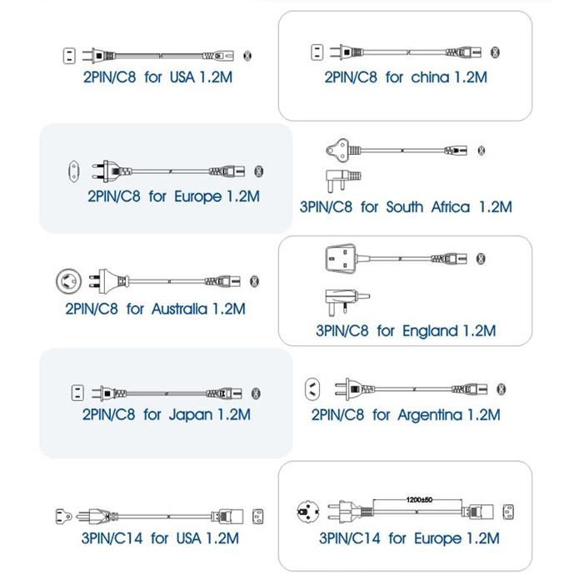
All the cables have to be sell with the switching power products.
All the cables line length is 1.2m,it can be modified with special specification.

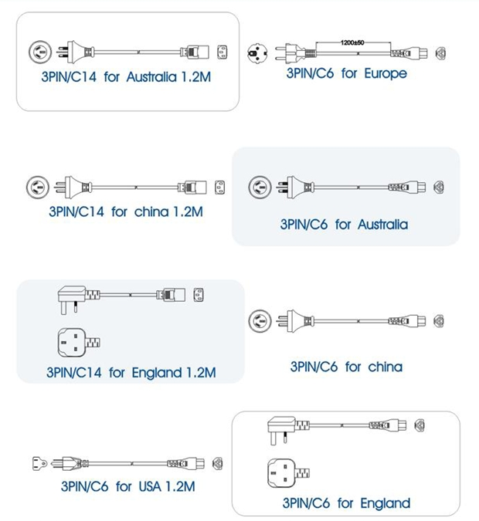

All the cables have to be sell with the switching power products.
All the cables line length is 1.2m,it can be modified with special specification.

